TÊN: Trần Thị Kim Duyên
MSSV: 087305001729
LỚP: CN2303E
MÔN: TRÍ TUỆ NHÂN TẠO

Đề bài:

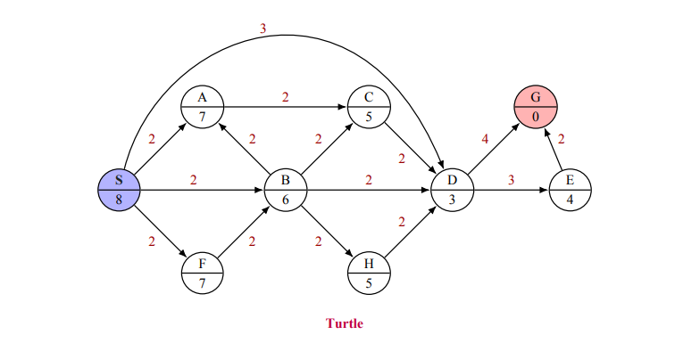

PP1: Best-first Search using Priority Queue
No. | Reached
No. | Expanded | Frontier [Priority Queue]
0 |  | S(0)
1 | S(0) | A(2) B(2) D(3) F(2)
2 | A(2) | B(2) F(2) D(3) C(4)
3 | B(2) | F(2) D(3) C(4) H(4)
4 | F(2) | D(3) C(4) H(4)
5 | D(3) | C(4) H(4) G(7) E(6)
6 | C(4) | H(4) G(7) E(6)
7 | H(4) | G(7) E(6)
8 | E(6) | G(7)
 | G(7)
S(0) → A(2) → B(2) → F(2) → D(3) → C(4) →H(4) → E(6) → G(7)

PP2: Greedy Best-First Search
No. | Reached
No. | Expanded | Frontier [Priority Queue]
0 |  | S(8)
1 | S(8) | A(7) B(6) D(3) F(7)
2 | D(3) | A(7) B(6) F(7) G(0) E(4)
3 | G(0) | A(7) B(6) F(7) E(4)
S(8) → D(3) → G(0)

PP3: A* Search
No. | Reached
No. | Expanded | Frontier [Priority Queue]
0 |  | S(0+8=8)
1 | S(0+8=8) | A(2+7=9) B(2+6=8) D(3+3=6) F(2+7=9)
2 | D(3+3=6) | A(2+7=9) B(2+6=8) F(2+7=9) G(7+0=7) E(6+4=10)
3 | G(7+0=7) | A(2+7=9) B(2+6=8) F(2+7=9) E(6+4=10)
S → D → G

